2Date 8/19 August 19, 2025
Feature normalizations [feature=input k har column ko ek feature kaha jayega]
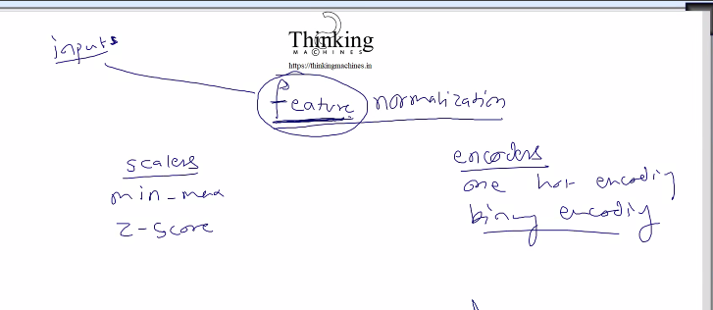
Koi numeric data he suppose x
To niche wale formula se value 0 and 1 k bich aa jayegi without loosig integrity
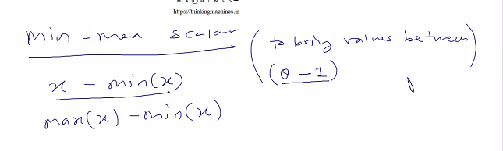

Agar hum iska function bnaye to what should function accept:
Data sting form me ho skta he to vo matrix me kese aayega,
Ya phir esa kre ki matrix me jb data aayega, to vo csv me numeric rahega, to hum bich me esi process dall de ki jo us string ko numeric me convert kr de.

But esa krna galat he.
To humko matrix of string lena pdega. But humare pas to double wala implementation he

To ye function , inputfile, input filename, outputfile, opfile name
Ye preprocessing wala kaam he, ye linear regression wala kaam n ahi he uske phle ka kaam he
Abhi file se krege.
Future: matrix ka esa implemetaion esa ho ki matrix ka har columm kuch alag data type aa ske.
Java me object,python me infer kr leta.
Abhi ye sb nahi krna , abhi sidha file pr kaam.
To To ye function k argument :
(input filename, outputfile name,Vetor, skiplines)
Kisi bhi scaling k algo k liye ye kaam kr jayega, only function k andr ka formula bdlega.
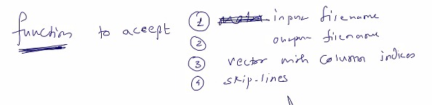

Ye huge data k liye bhi chlega, matrix lete to usko load krne me hi fas jaate.

1.minmax: formula upar he
2. z-score: ye function bhi vo 4 argument accept krega.
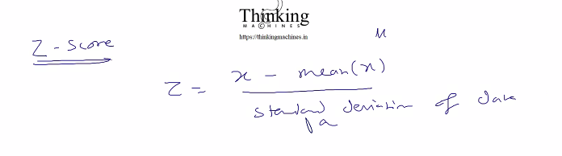

Ab standard deviation nikalna:
1 compute mean
2. substract mean from original value
3.isme negetiva aayega to usko kkhtm krne k liye square
4. again mean pta krna he isko variance kaha jayaega.
5. apply squere root output of step 4
Ye 5 step k baad jo aayega vo denominator me aayega
Ye sir ne baar bar likh k rat liya he.
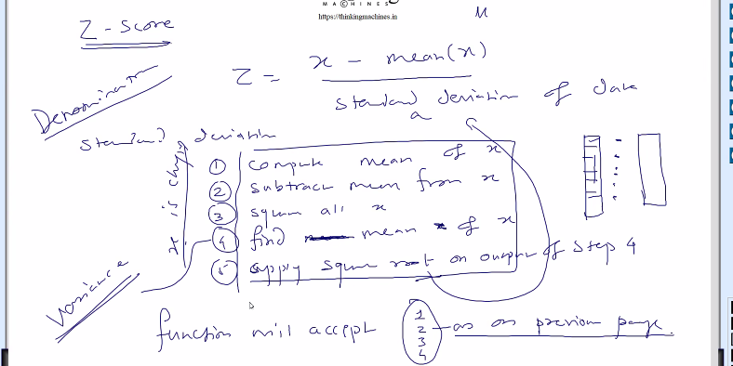

Ab c me likh me likhee to time consuming he and or tech me krege to jldi ho jayega

Ab next encoder ki baat:

Maan to koi color data he ,
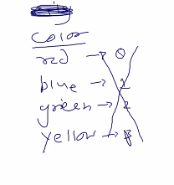
Encodeing k liye number de do but ye galat he .
Input me koi column he jiski value in charo me se ek ho skti he

Tranining me mathematics biased hoga high weight ki taraf

To one column will be removed and 4 column will be added.

Gender column he : uske against male feamale
O inko hata ke
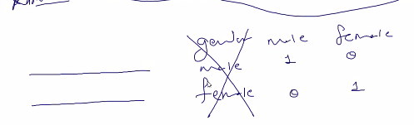
Gender male female tha.
To gender, male, female ko hata k naye column bnao male and female
And jis row me ramesh he usme male ko 1 and female ko 0
Jis me rekha he usme male ko 0 and female ko 1

Same for 4 colore jisme jis type ki value he usko 1 baki sb ko 0

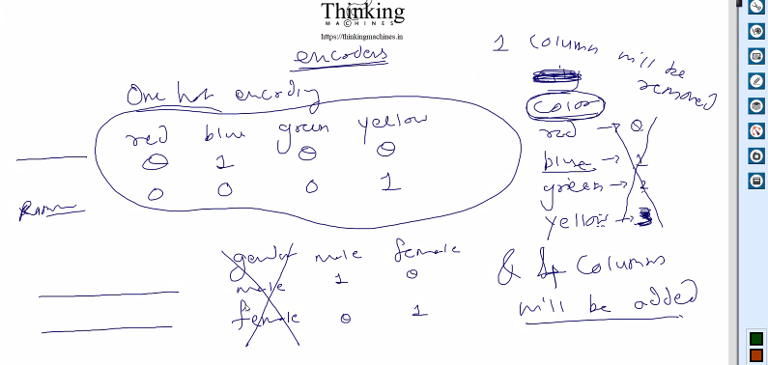

Isko one hot encodeing bolte he:
Isk e liye bhi same argument wala function
Koi feature he jiske pass 95 alag alag string he o 95 columns bd jayege.
Dimesion bdega to processing time khayega.
To iska solution he binary encodeing

Binary encoding:
Color
Red
Blue
Green
Yellow
Cyan
White
Black
Orange
Gray
Sbko eke k code de he: but vahi baat jisi value higher uski side biased rahega.
Abhi say 0-7 to max code 7 he
One hot column k hisav se 8 colum bn jaate
But ayaha pr 3 column me kaam ho jayega. 2^0,2^1,2^2,2^3
One column goes and 4 columns come
Color-3, color-2,color-1,color-0 power k hisab se naam

Kisi ka color cyn to uska code 4 tha to char k binary nikal k likh do, utne bit aayega
Pr har bit ek column he
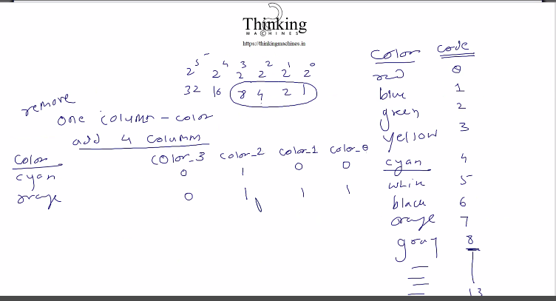

Iske liye jo function bnega vo kya accept krega.:
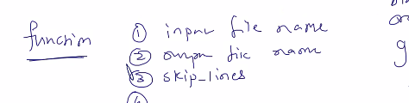
And 4th chx kya paas kre? Vector of indices
Daaset me kuch columns he jiske agains sirng pdi he to unhi columns ko hujme encode krna he
Jiske agains sring pdehe
But column me jo color name ki string pdi he usme kis color ko kya code dena he
Algo code de de ya user code specipye kre
User ko unique set of string , and then create the code for each
To algo decide kr le and user ko gyan de de ki kiska kya code he.

Jitney column ki baat kri utni file bnani pdegi and us
s 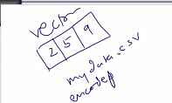
saamne wale ne specify kiya ki inin columns pr encoding krni he.
To 3 file bne and usme feature value and uska code
Utni file bna do ya csv bna k de do ,
ya phir samne wale se hi file k naam bulwao.
Ya humare naam se bnai hui file ko remane krna

Abhi to hum hi naam generate krege.
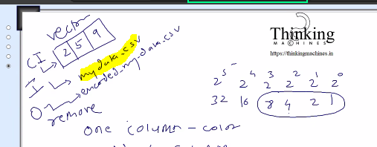

Data analyst ye kaam krta hoga, usko ya to gui tool ya excel pe kaam and formula ki training di jaati hogi

Date 8/23 , August 23 2025
Normalization ki coding: stockastic wala complete krnahe

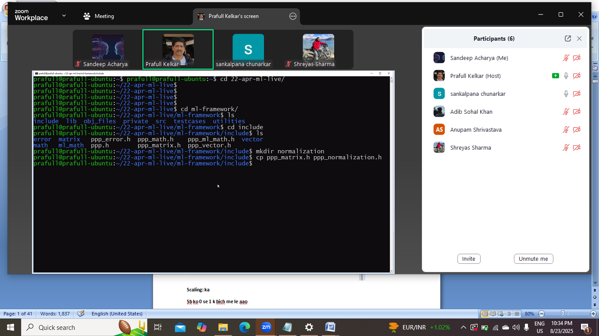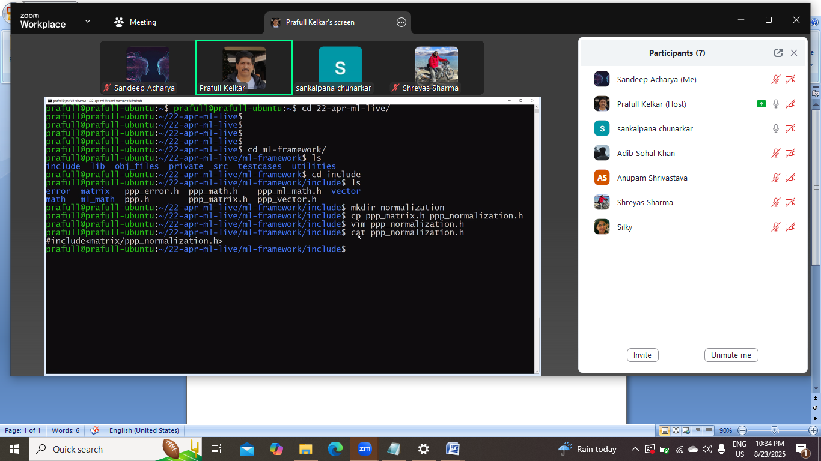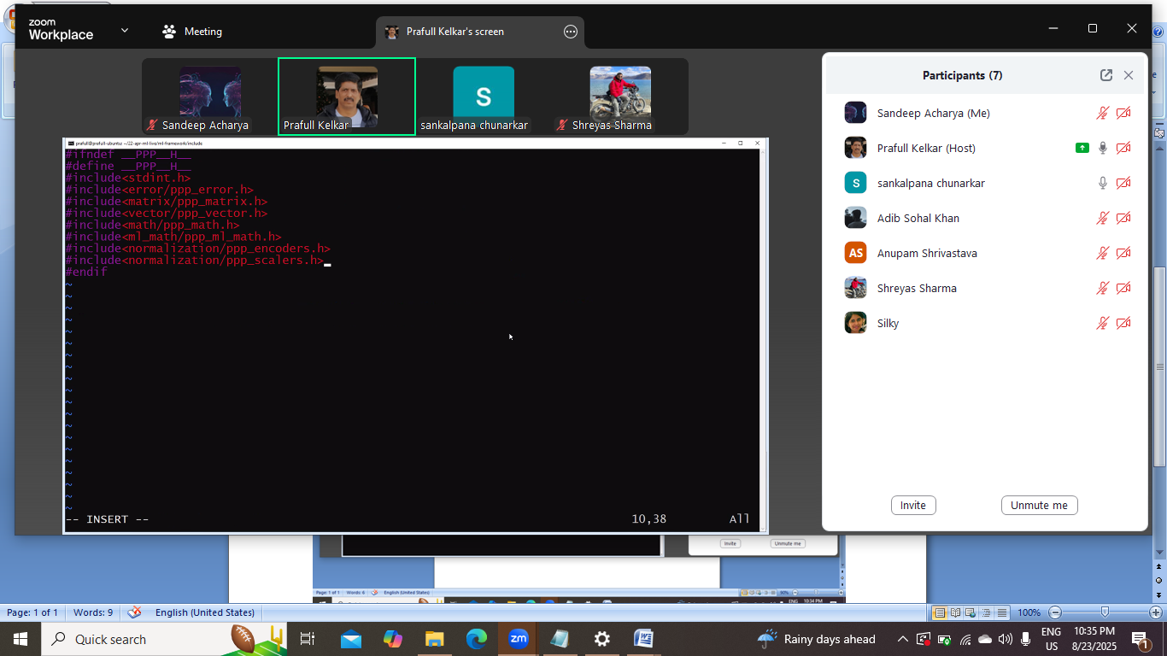
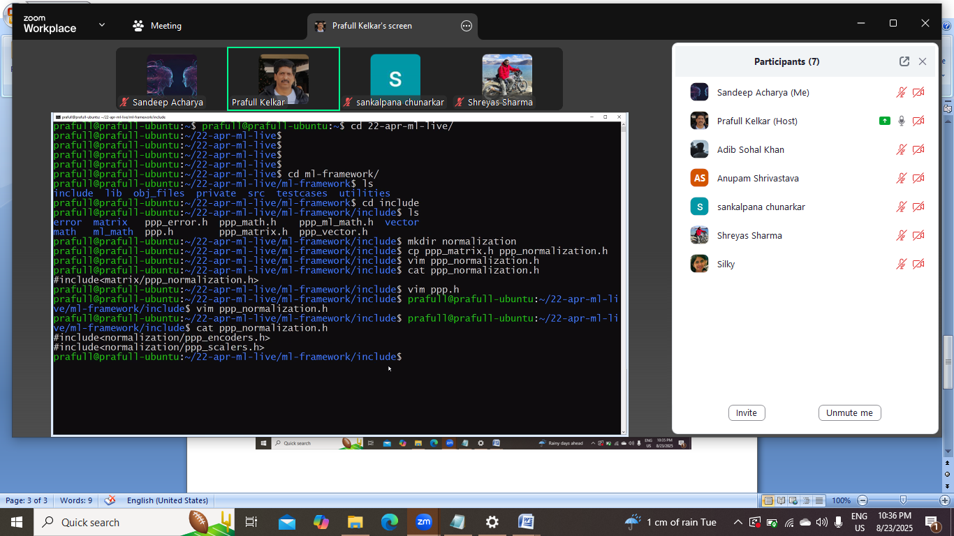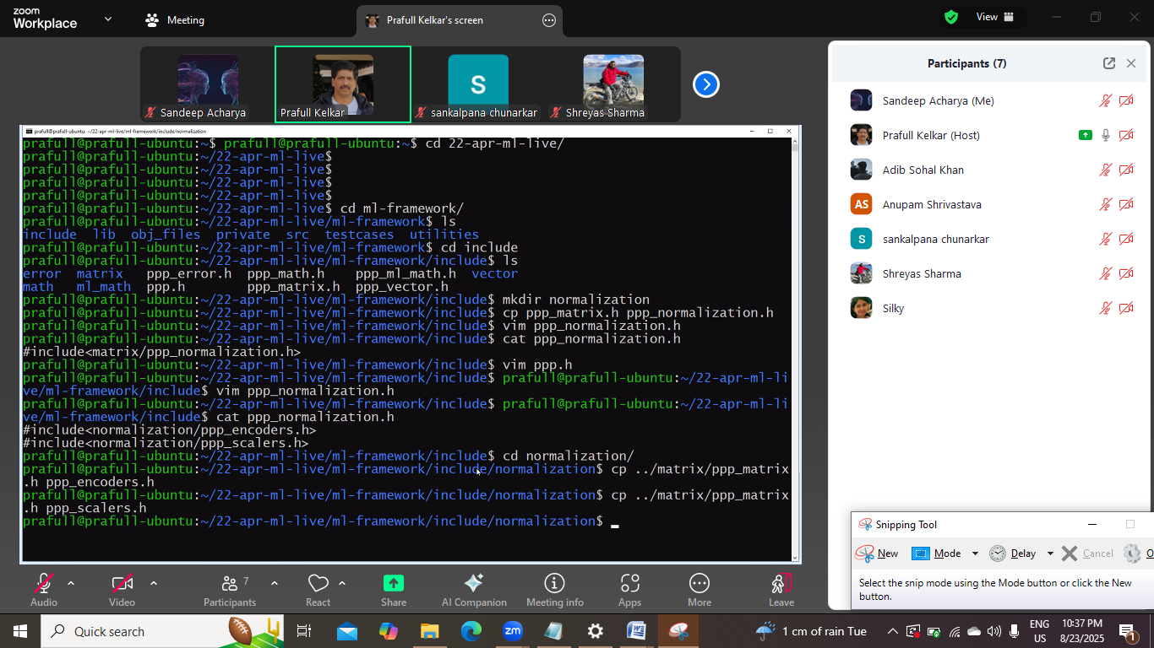

Encoder.h ka code: binary and one code encoding

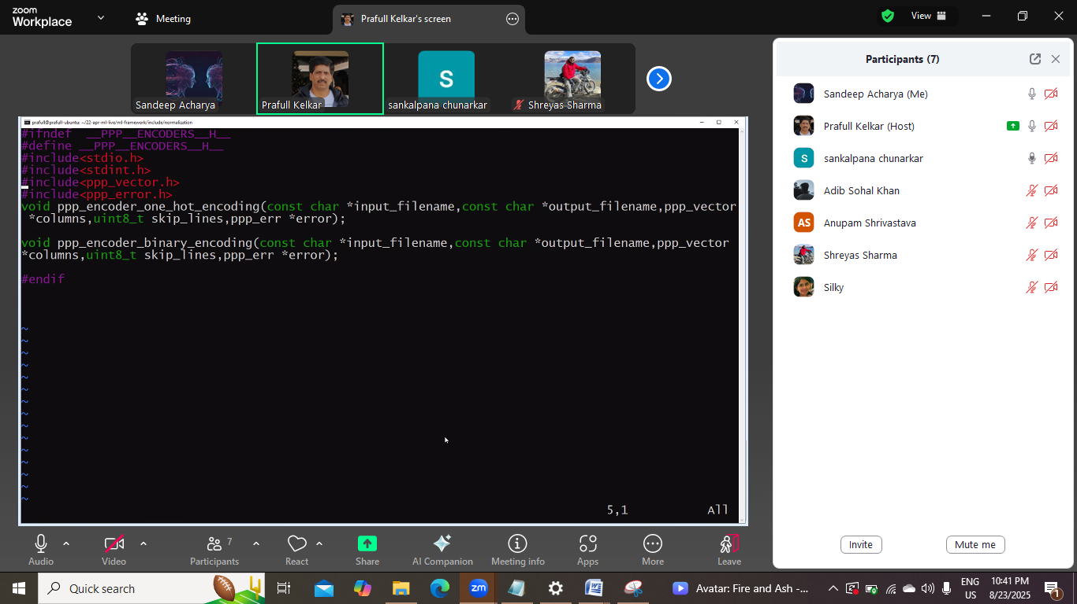

Scalar.h ka code
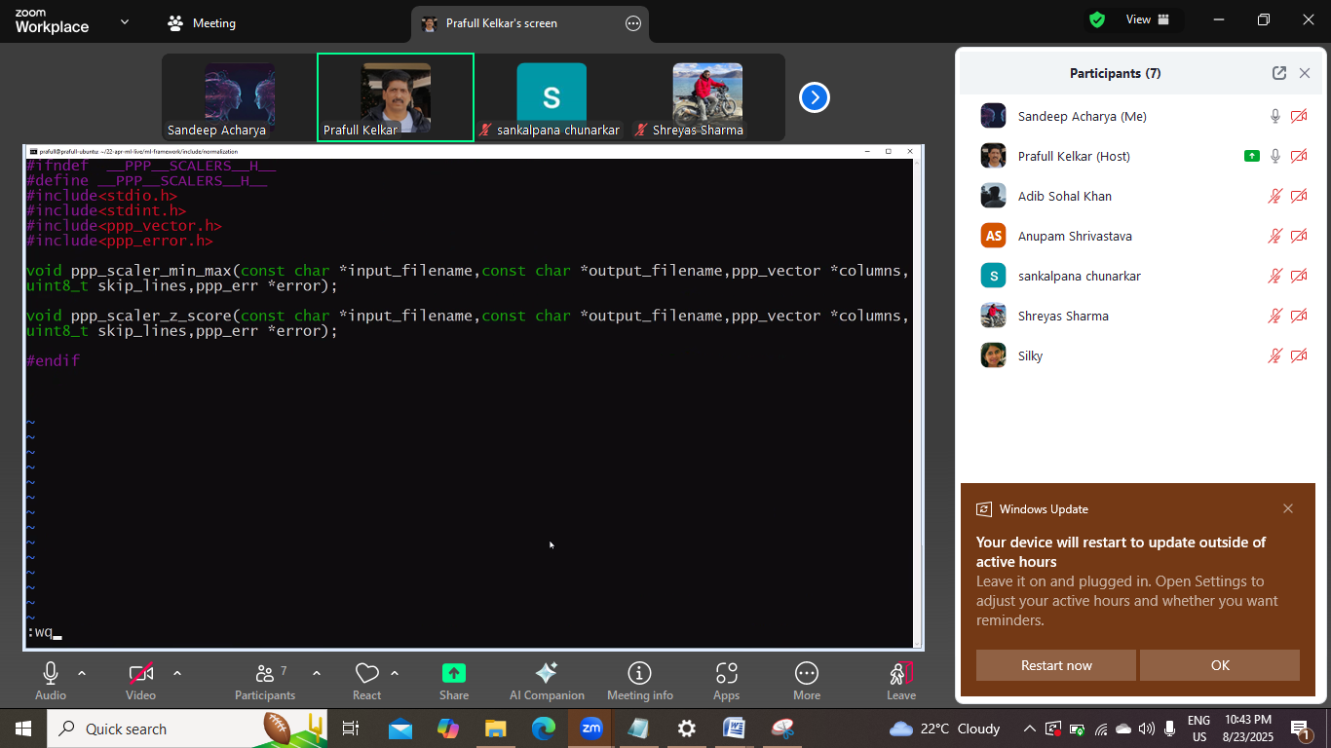

Implementation:
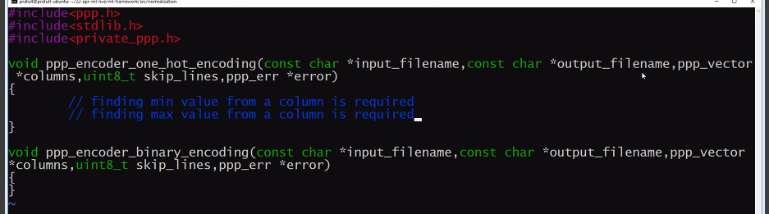
Isme min max ka function likhe to vo kya le, vector? But pura data to load nahi ho skta.
To file pointer lege. And file se dudege.
Scaling krne k baad scaled file bnegi.
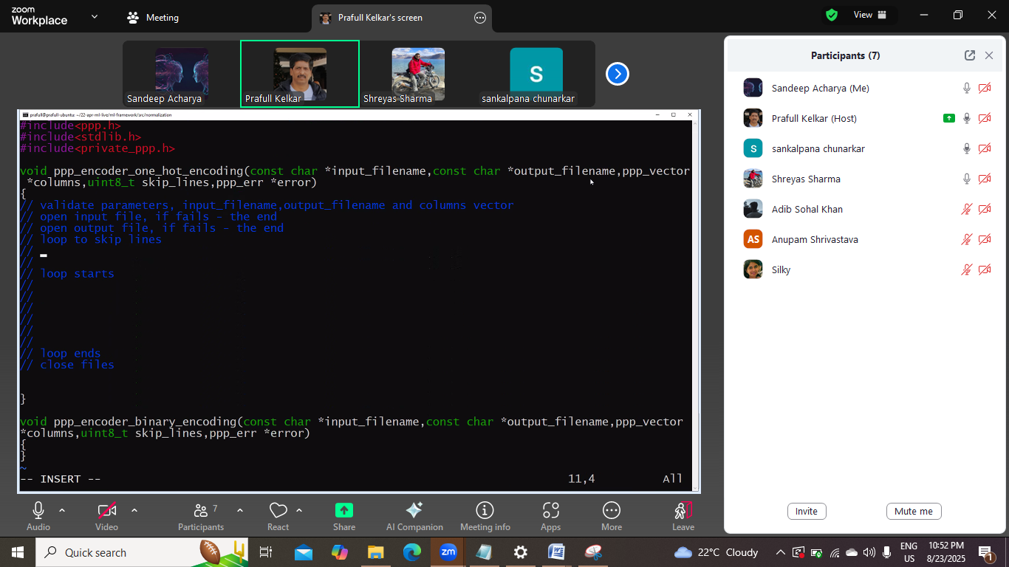ye sudon scaling wale ka he.
Ye niche wala sahi he

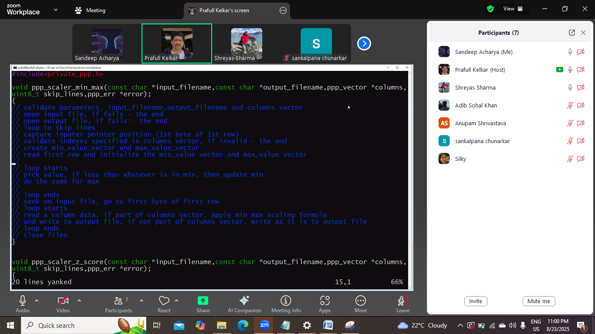

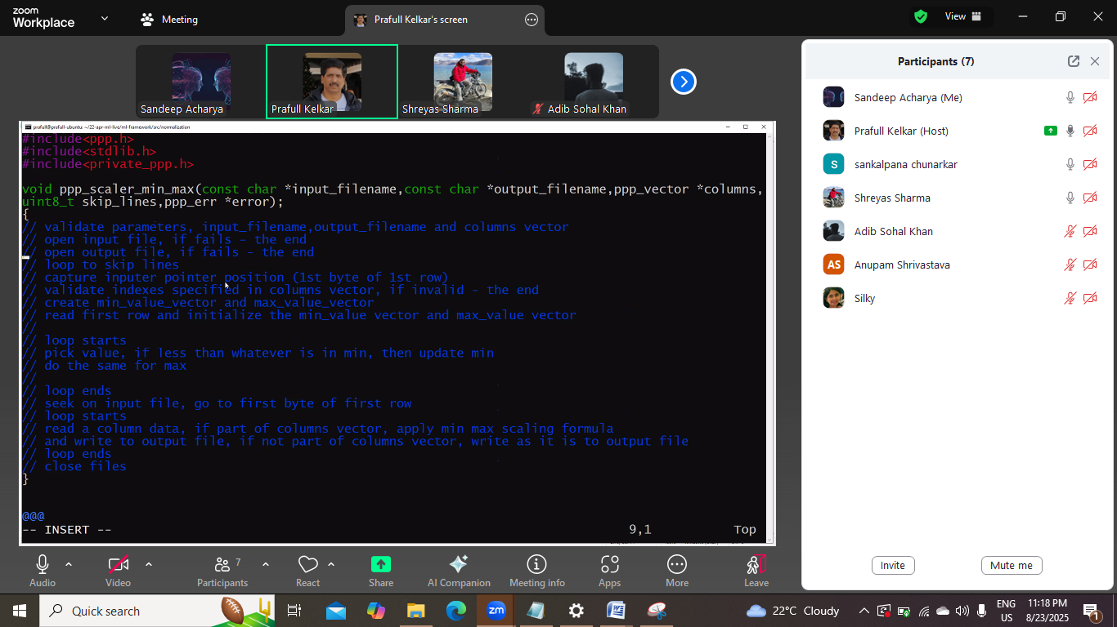
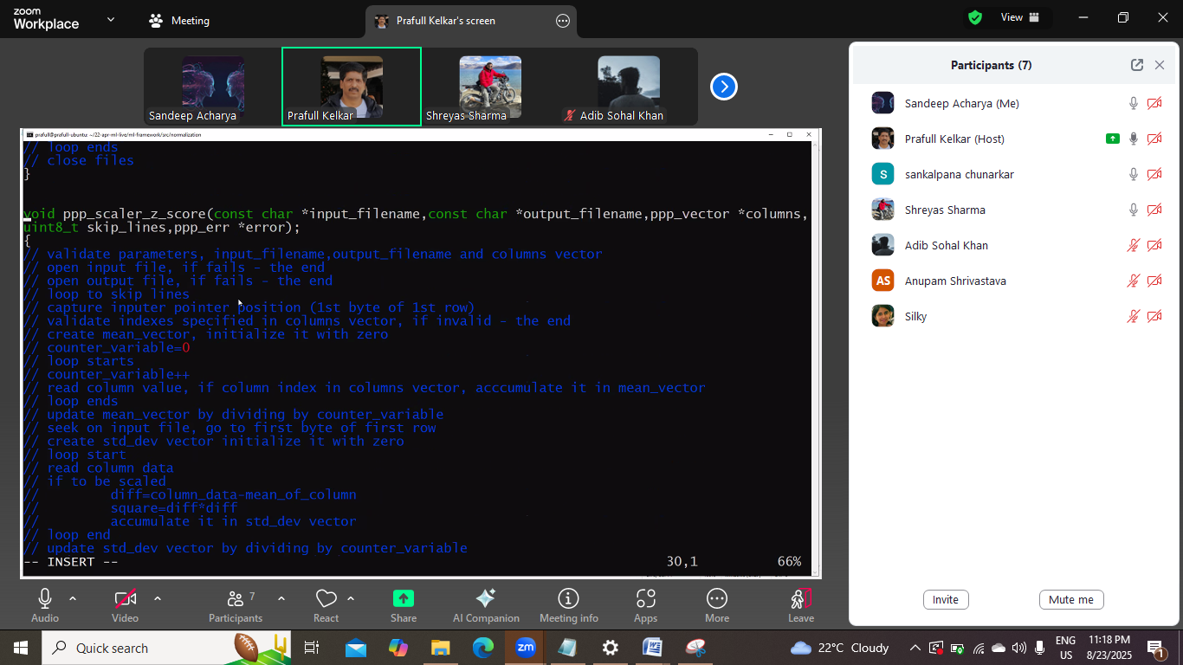
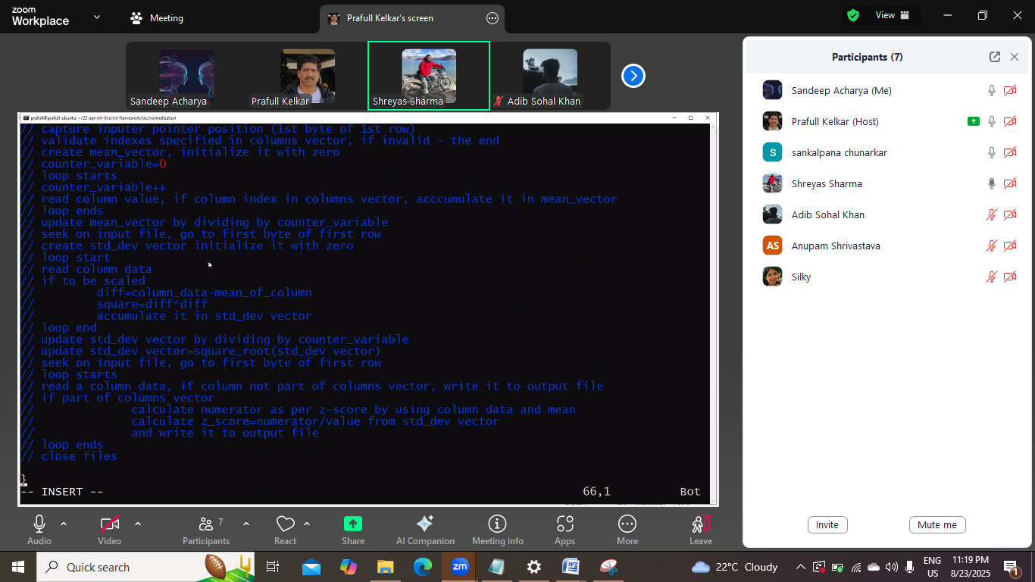

Encoding me jhanjhat.
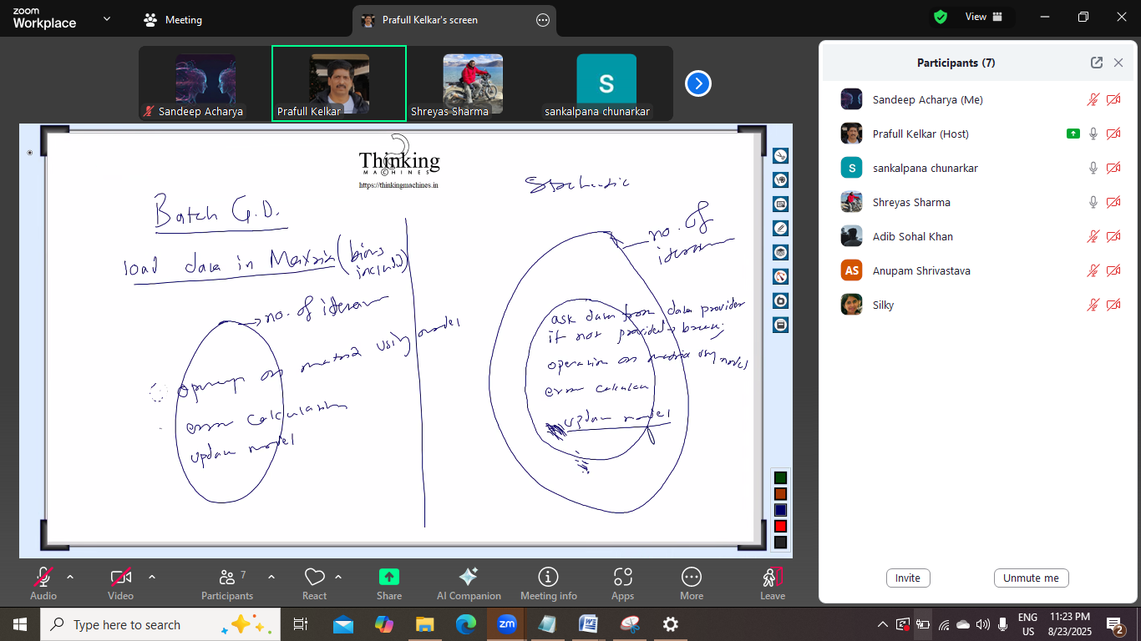
Update model andr kandr model bahar
Batch gradient me pura data ek sath, pura ek sath nahi mil raha to vo mini batch GD ho jayega
Isiliye stockatstics ki taraf bade

Batch GD:
Iteration:
Operation on matrix u sing model
Error calculate
Update model
Stockatcis:
No. of iteration:
Data provider feed data:
Ask data
If no t provided breadk
Operation on matrix using model
Error calculate
Ab model update yaha krna he
Ya model update yaha krna he.

Date 8/26 August 26, 2025
Lets implement this
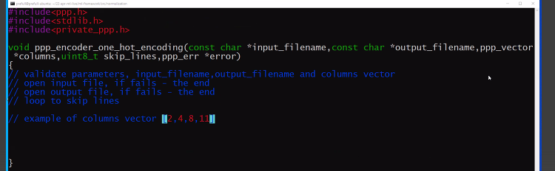
Suppose 2 index wala colum lete he and saree cell pr traverse kr k

Set me dalege and set se decide ho jayega ki ab kitne column bnege.
Ek ek kr ke pdege to galat ,
To create an array of sets , accoding to size of the columne vector e.g. in case of above image we will take array of size 4.
Set is of type string.
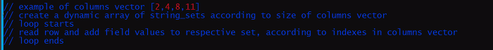
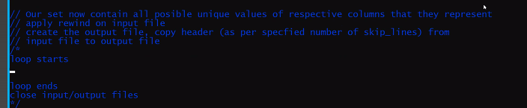

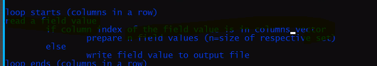
.
Read a field value means
If column index of the field value is in column vector means

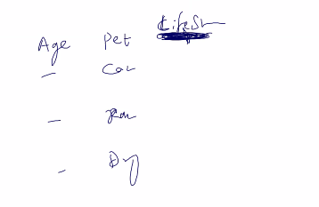
Lifestyle is outputwala
Ab on ho tencoding se jo bnega vo
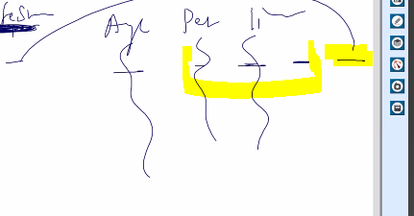
Ese bnege
Ab yaha header bigad jayega., header ko handle krna pgdega.
To uske liye vector of stirng lege
Abhi skipline kr rhe he to chl jayega but , header wala part will be intact
To new column should be
Age pet1 pet2 pet2 lifestyle
Ya
Age petcat petrat petdog lifestyleho
Jo naye column ka naam rahega originalname_setkivalue.

But ab jo vo line skip krwa raha he vo header nahi he and combo of kuch ho like title.
Standard csv parser bhi dhng se parse nahi kr payega.
Aajj ka ss
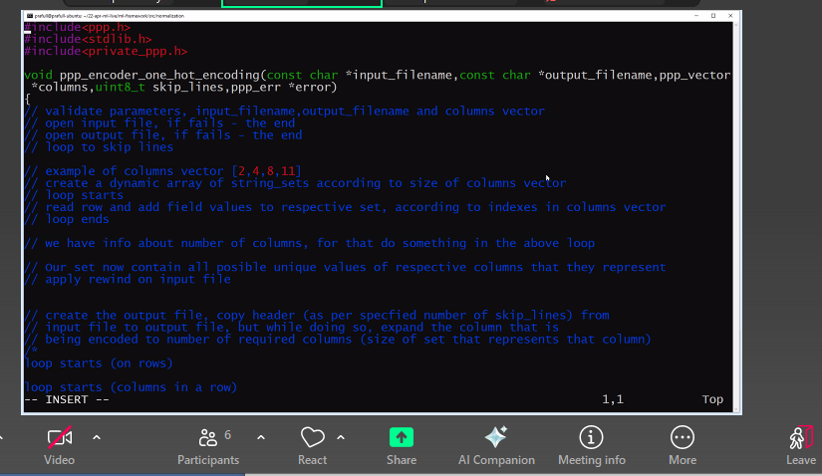
Ab vo binary assin krna he

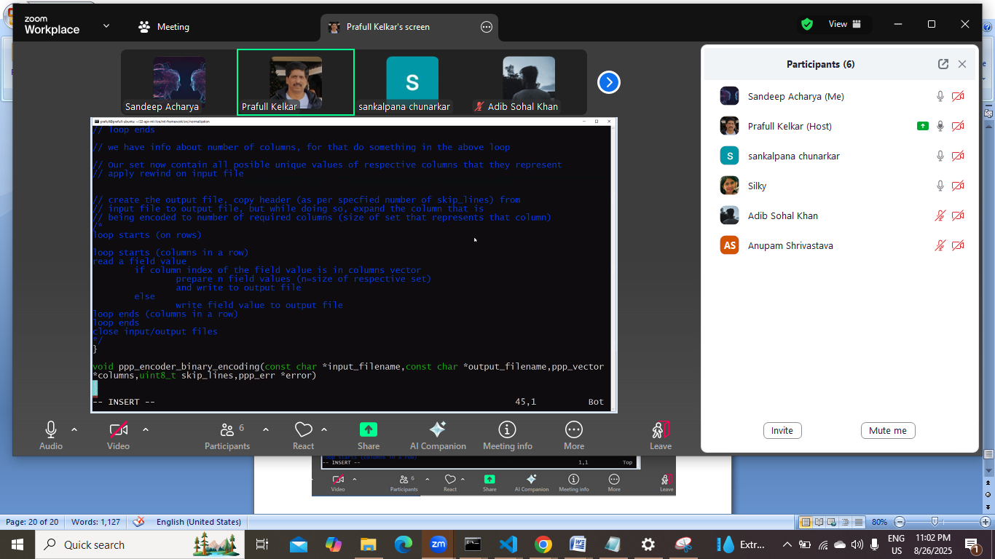
Ek decision lena he ki usi hisab se csv bnani pdege.
Nah ito phir vo csv parser bnane wali baat aa jayegi.

Date: 8/28 august 8 2025
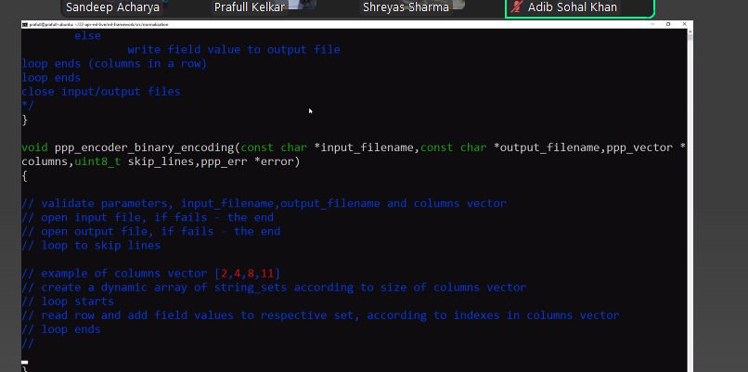
Kahani yaha k pahuchne k baad 4 sets ready ho jayega.

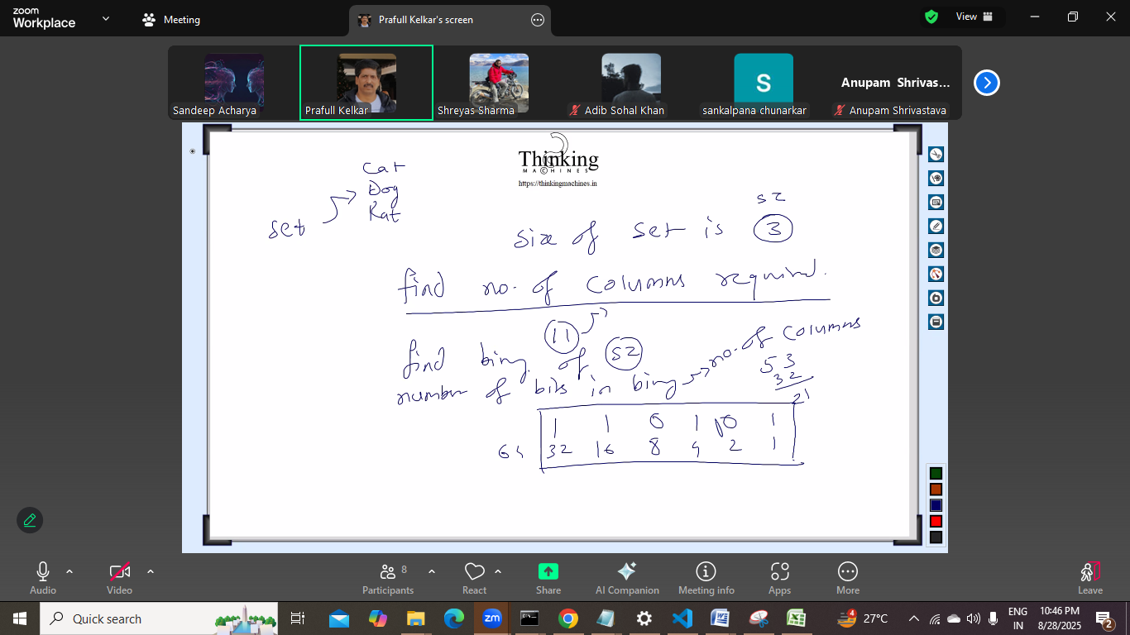

Abhi sets k binary pta kiye loop laga ke
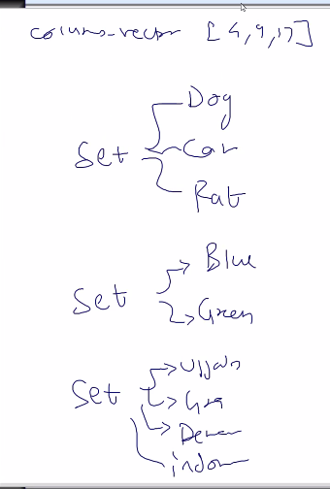
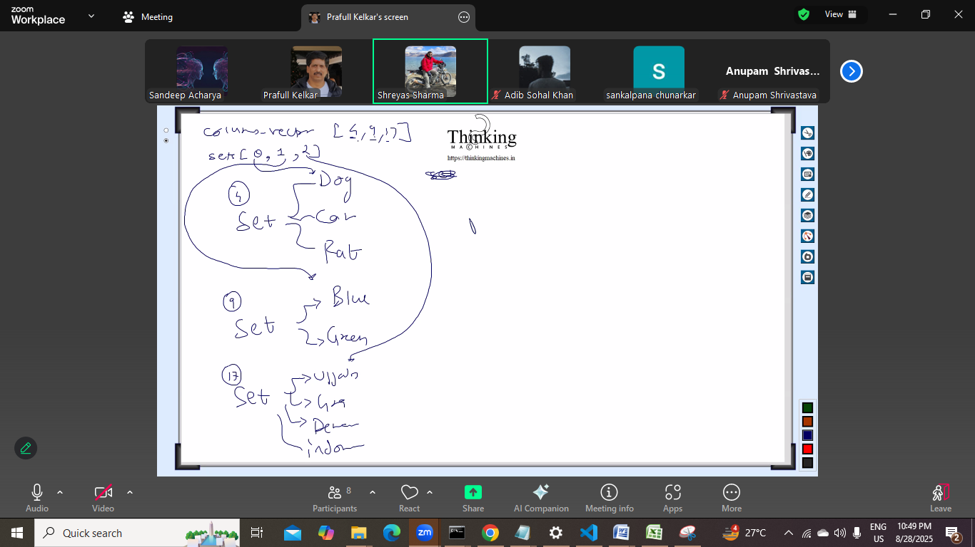
4 number column ka data set 1 me
9 number column ka data set 2 me
17 number column ka data set 3 me
Read kr liya and set me unique of that columns
Ab numners of columns ka binary bnaya
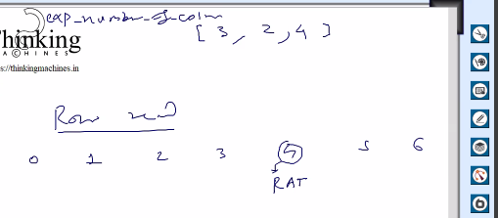

Hum ek output file bna rahe he
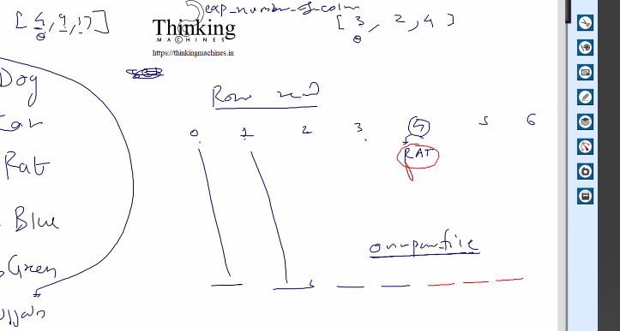

0,1,2,3 [4,9,17 ] me nahi he to unko as it is chhap diya op file me
4th column me aayae to vo mila [4,9,17] me
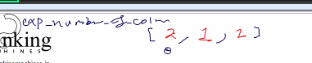
And ye [4,9,17 ] me 0th pr he and udr upar wali image me 0th pr 2 he , to 2 columns bdege,
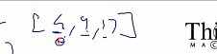
Similarly 9 wale k liye 1 column lgega, and 17 wale k liye 2 lagega
Ye 2,1,2 kese aaya

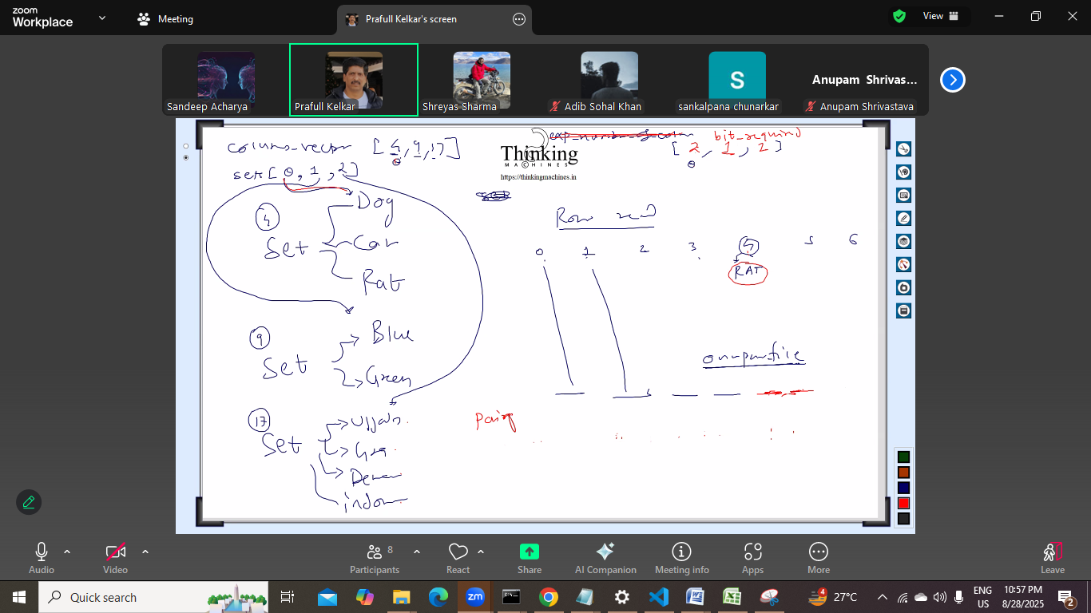
First set me 3 element to 2 digit me aa jayega [00 10 01 11] =2
Second set me 2 element 1 digit me aa jayega like [0,1]=1
Third me 4 element vo bhi 2 digit me aa jayega al like [00 01 10 11]=2

Set ki size , then size-1 ka binary coz 0 base le rahe he.
Size-1 ka binary nikal k, usme jitney bits aa rahe he us length ki us pair me string rahegi.

- Columns ka vector jinki encodeing krni
- File se data sets me
- Set pr loop laga k pairs wala ds bnayege.
- Content pair wale ds me search kr ke us string ko udr file me likh dege
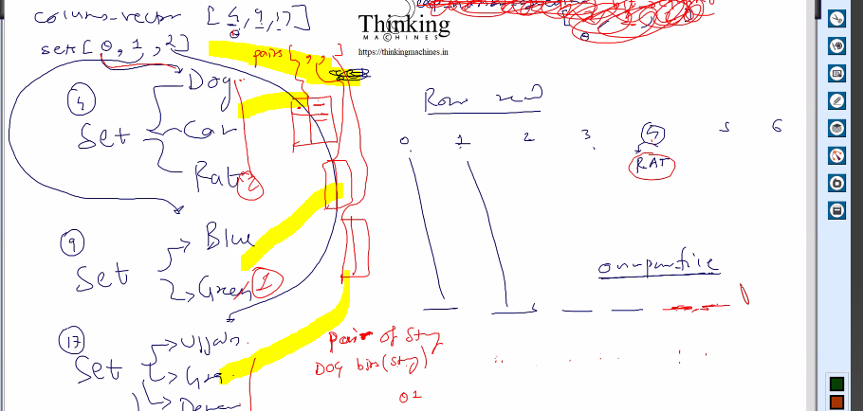

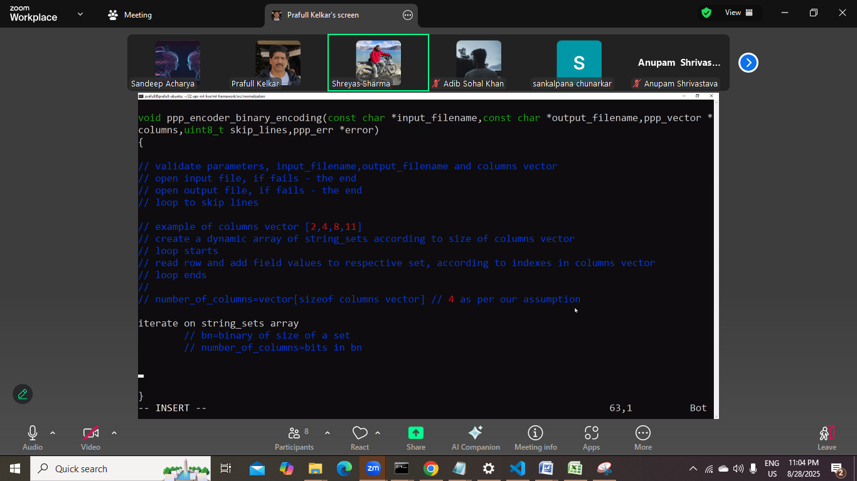

Abhi problem kya bachi he:
Dog cat rat , hum jo pair bnayege usme 00 01 10 rkhege
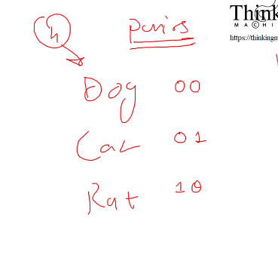

Ab ek file bnayege:
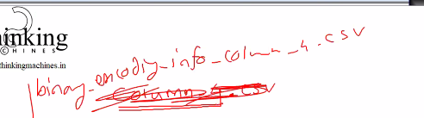

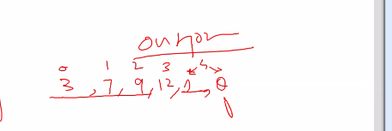
4th me rat tha to usko 1,0 me fela diya,
But ye to misleading ho jayega, user ko kese smjh aayega.

Ye niche wali file
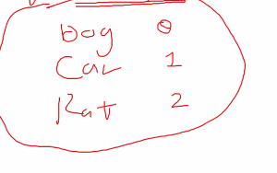
Ka kya benefit:

User ko esi info mile: column 4 expanded to 2 columns
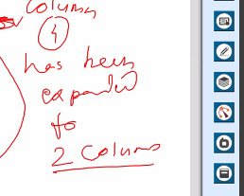
And then usko dog k against 0 and 1 milege 2 columnl.
4th column me [dog and cat] mila to iske 2 col bnega and usme 0 1 se represent hoga.
50k rows ki 25 files
Ek ki encoding kroge , and jo tay hua he vo duser k liye use hona chaiy

Ya phir esa:
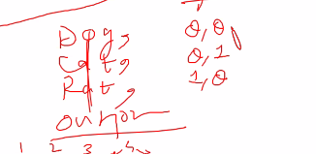

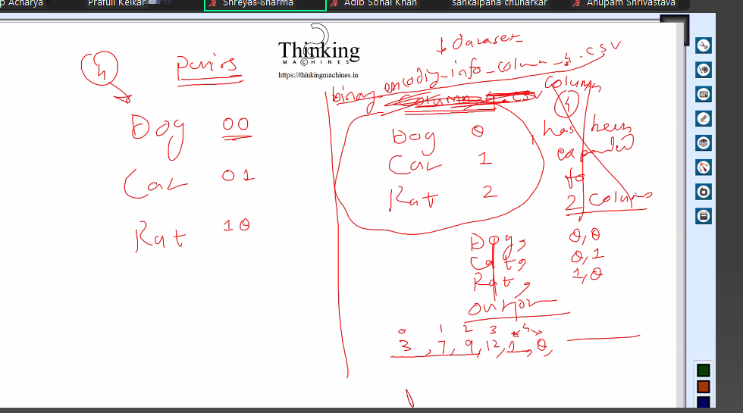

Next session Tuesday,: 4 sude code , 2 scalar, 2 encoders
Set and pair phle bna liye jayege,
Set me bhi tree ya hashing ka algo , string se hashcode generate ho
Dynamic data me tree hi maintain krna feasible he, red-black tree.
Sir to simple growing array bnayege.
Generic redblack tree ki lib bna rkhi he sir ne.
Naam uska set rahega, jb humari ichha ho tb vo piche ka algo bdla jaa skta he.

Next lecture: Tuesday: 2 september 2025 cancelled next conducted on 4th sept

